**Academic Year: 2024-25 Semester: V**

**Class / Branch: TEIT Subject: DevOps Lab**

**Name of Instructor: Prof. Sujata Oak**

# Experiment No. 6

**Aim:** To implement Jenkins Master-Slave Architecture with Scaling.

**Theory:**

**Need of Jenkins Mater-[Agent-slave] Architecture:**

When we build the Jenkins job in a single Jenkins master node then Jenkins uses the resource of the base machine and if no executor is available then the jobs are queued in the Jenkins server. Sometimes you might need several different environments to test your builds. This cannot be done by a single Jenkins server. It is recommended not to run different jobs in the same system that required a different environment. In such scenarios where we need a different machine with a different environment that takes the specific job from the master to build.

On the same Jenkins setup, multiple teams are working with their jobs. All jobs are running on the same base operating system and the base operating system has limited resources. Also, we don't want to put our personal data on the same system where other teams can read.

#### Jenkins Distributed Architecture:

Jenkins uses A Master-Slave architecture to manage distributed builds. The machine where we install Jenkins software will be Jenkins master and that run’s on port 8080 by default. On the slave machine, we install a program called Agent. This agent requires JVM. This agent executes the tasks provided by Jenkins master. We can launch n numbers of agents and we can configure which task will be run on which agent server from Jenkins master by assigning the agent to the task.

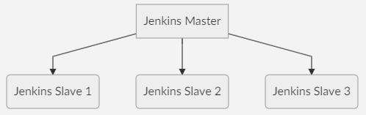

**Jenkins Master and Slave Concept**

A Jenkins master comes with the basic installation of Jenkins, and in this configuration, the master handles all the tasks for our build system.

If we are working on multiple projects, we may run multiple jobs on each project. Some projects need to run on some nodes, and in this process, we need to configure slaves. [Jenkins slaves connect to the Jenkins master](https://dzone.com/articles/asynchronous-master-slave-replication-of-postgresq) using the Java Network Launch Protocol(JNLP).

The Jenkins master acts to schedule the jobs, assign slaves, and send builds to slaves to execute the jobs.

It will also monitor the slave state (offline or online) and get back the build result responses from slaves and the display build results on the console output. The workload of building jobs is delegated to multiple **slaves**.

**Steps to Configure Jenkins Master and Slave Nodes**

**STEP1: In Jenkins Dashboard Click on Manage Jenkins -> Manage Nodes**



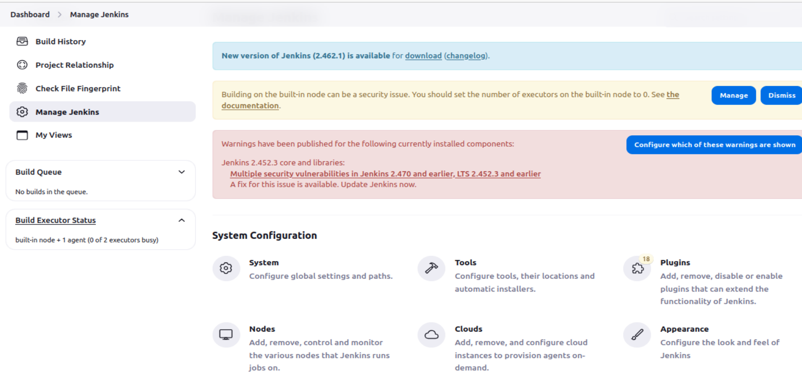

**STEP 2: Select New Node and enter the name of the node in the Node Name field.**

**Select Permanent Agent and click the OK button. Initially, you will get only one option, “Permanent Agent.” Once we have one or more slaves you will get the “Copy Existing Node” option. Click Create**

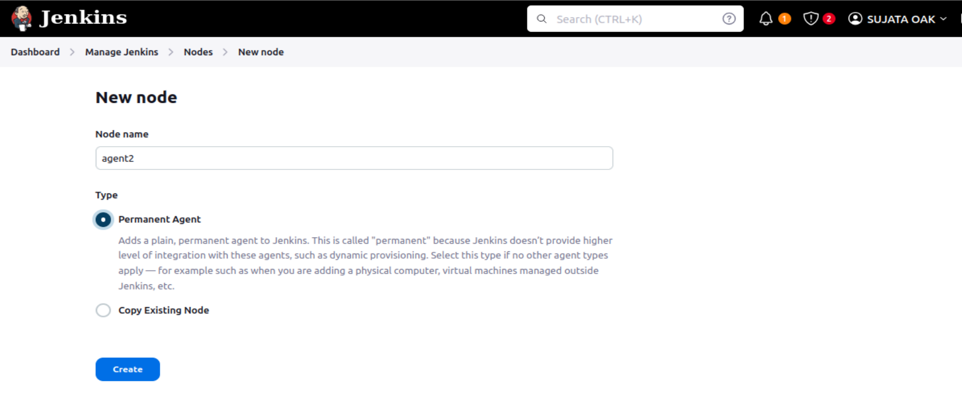

**STEP3: Configure node with below details:**







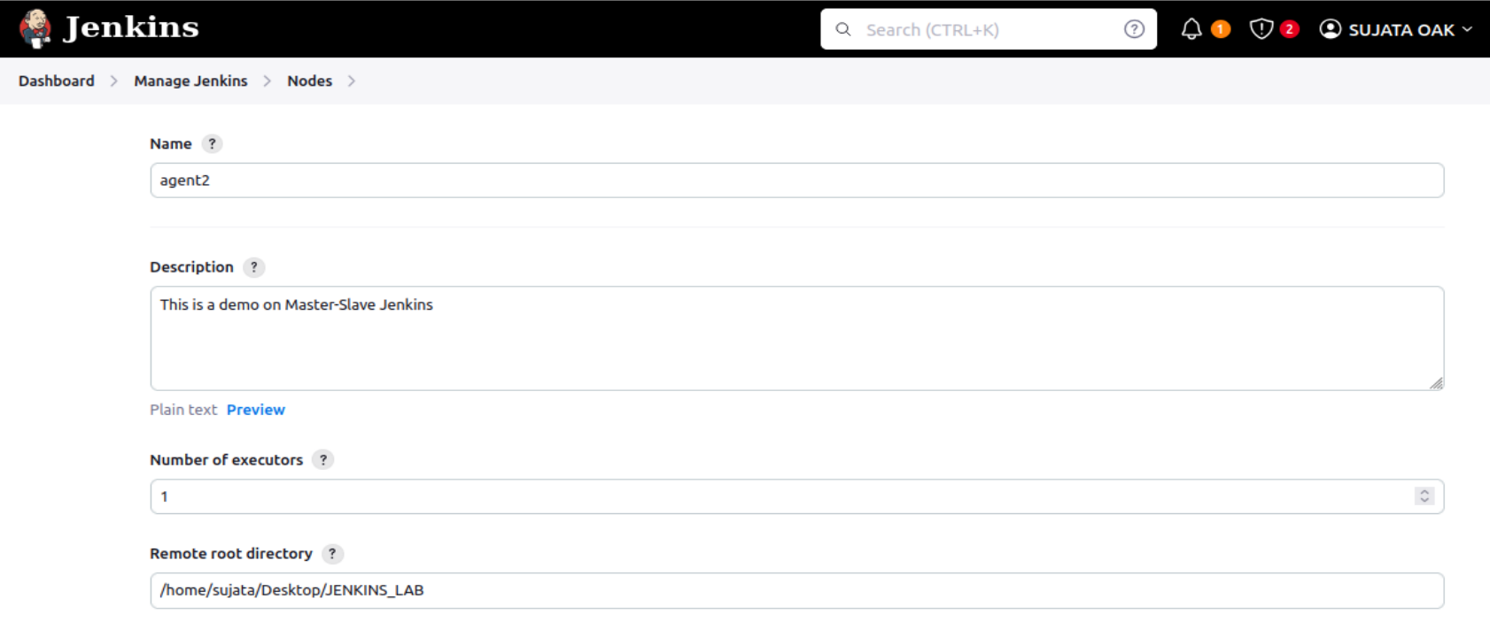

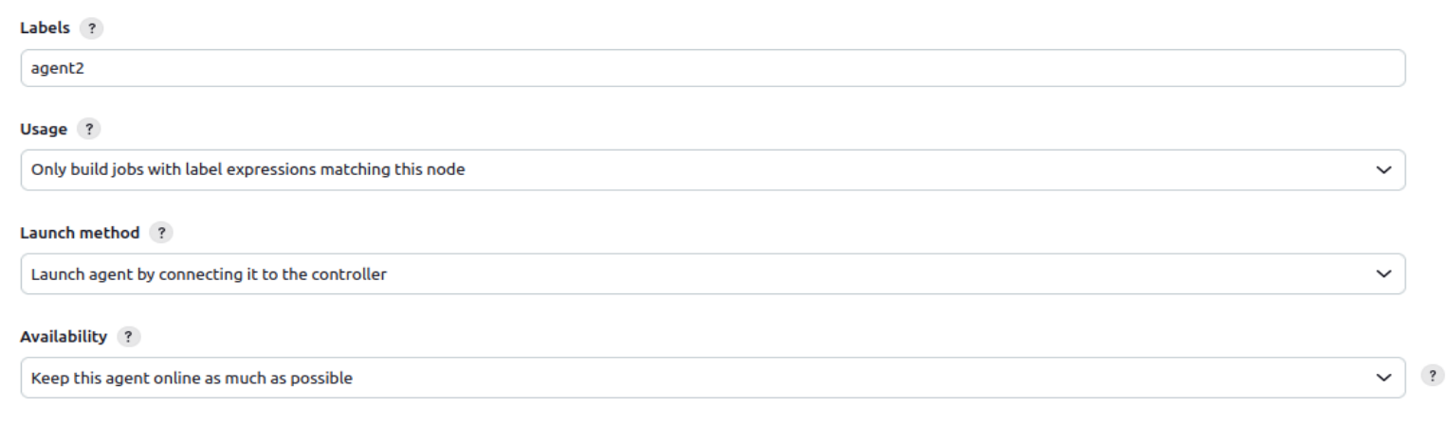

**Under ‘Node Properties’, provide jdk path.**

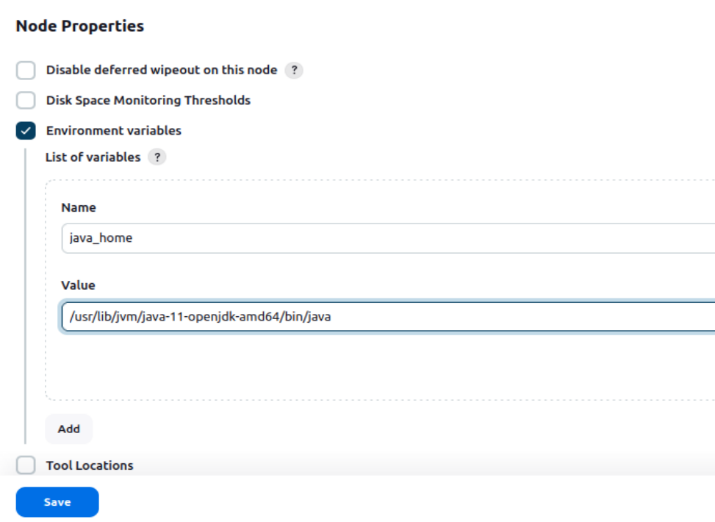

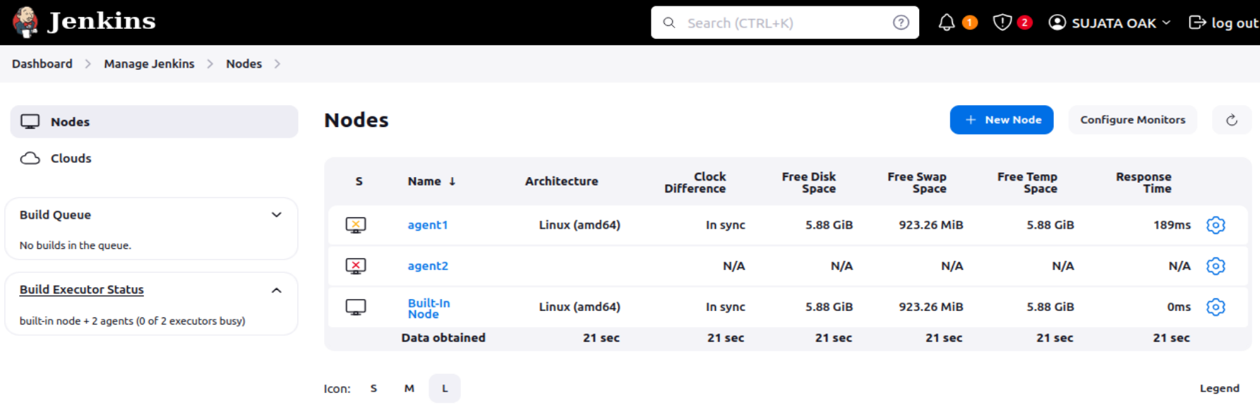

**STEP4: On click of ‘Save’ will display the below page with error message. Here Jenkins connect with Slave node using Java Web Start and it needs a port to establish the connection.**

**To configure JNLP port in global security. Now goto Manage Jenkins -> Security**

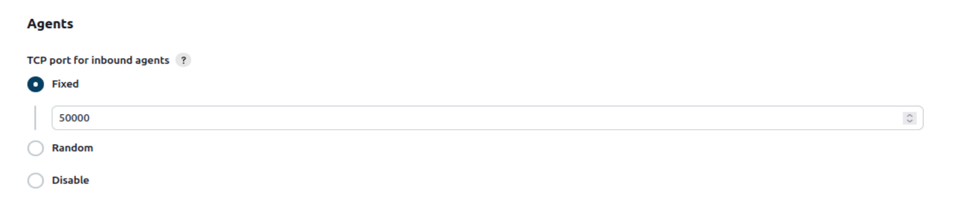

**This port has to be allowed to access across firewall, so from Master terminal run the below command,**

***sudo ufw allow 50000/tcp***

**This command will allow port 50000 to listen for request.**



**STEP5: Again coming back to Jenkins and navigate to Nodes -> agent2 which will display two ways to connect with Agent node.**

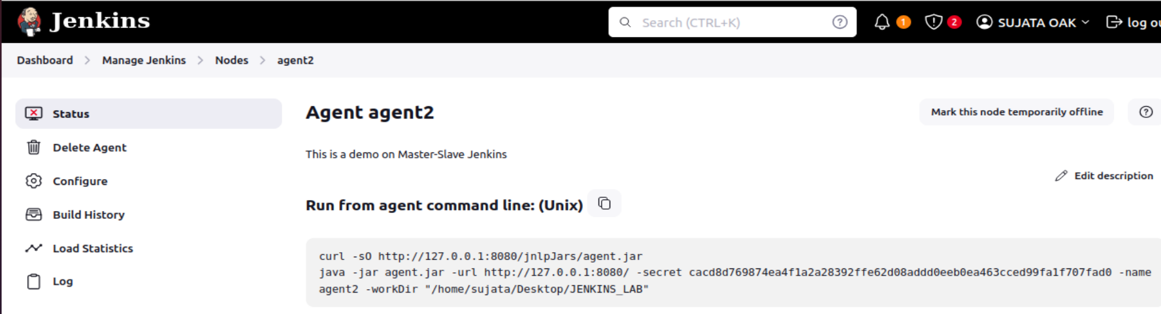

**To establish connection, run the below command**





**OUTPUT:**

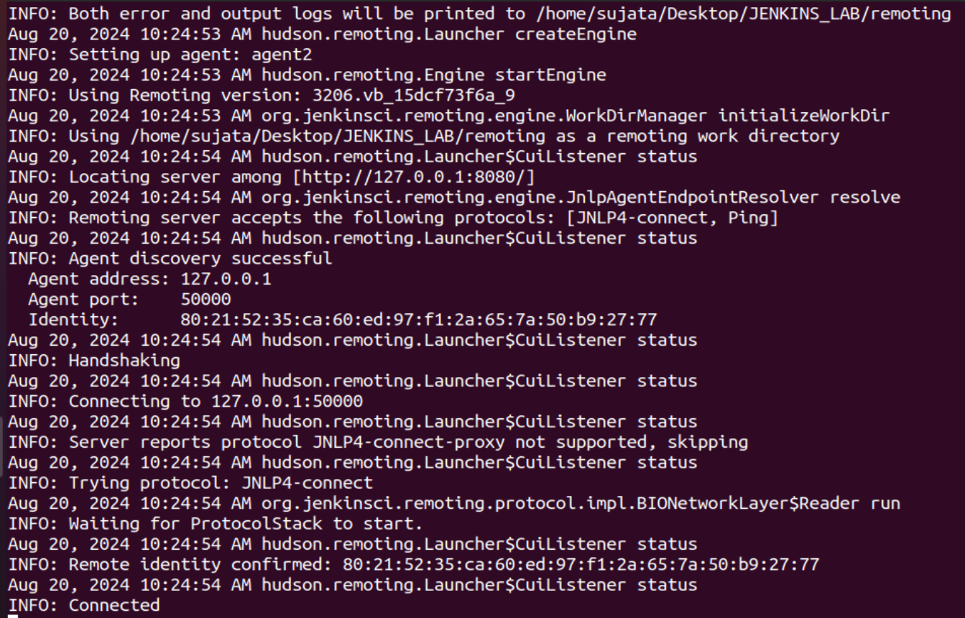

**This will establish connection with the configured Slave node.**

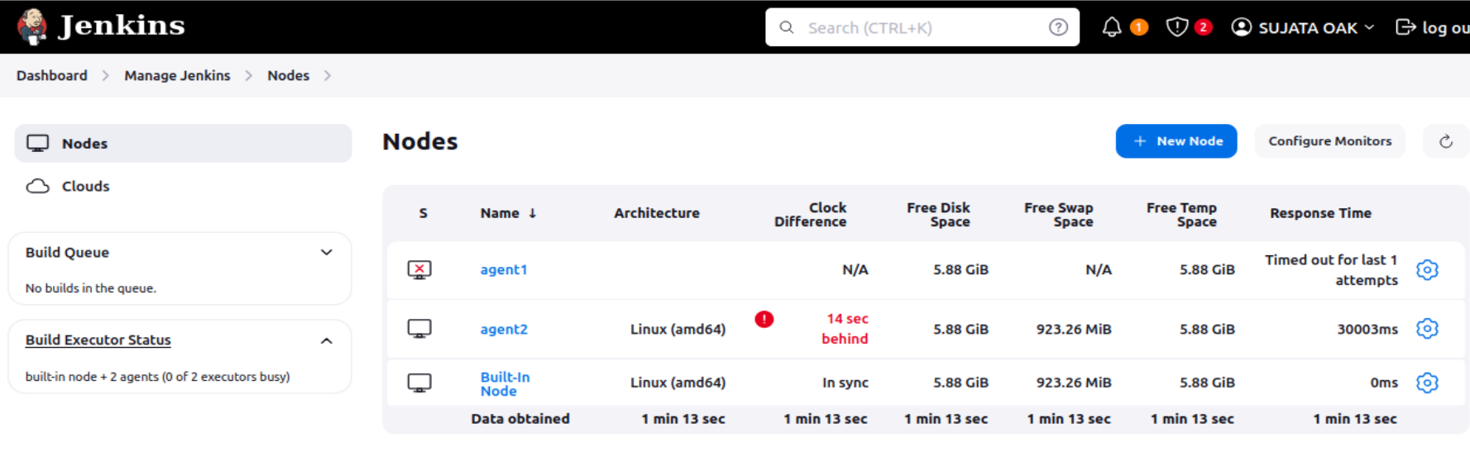

**Now Jenkins Slave node is ready to run any job. This node’s label name should be mentioned in the corresponding Job configuration as below:**

**STEP 6: Create a New Job in Jenkins dashboard**

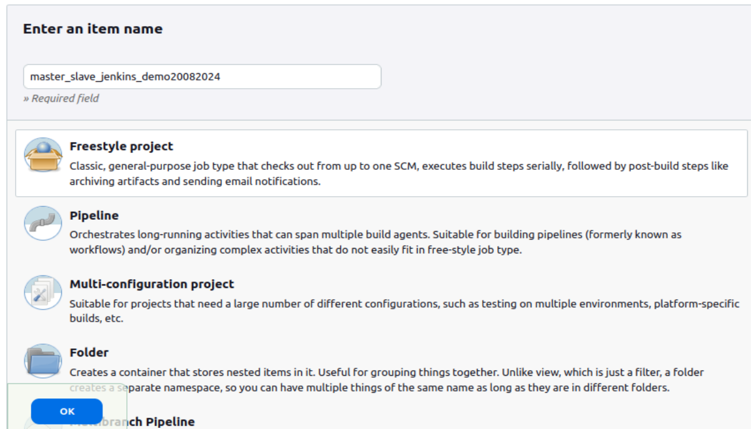

**STEP 7: Configure the page with following:**



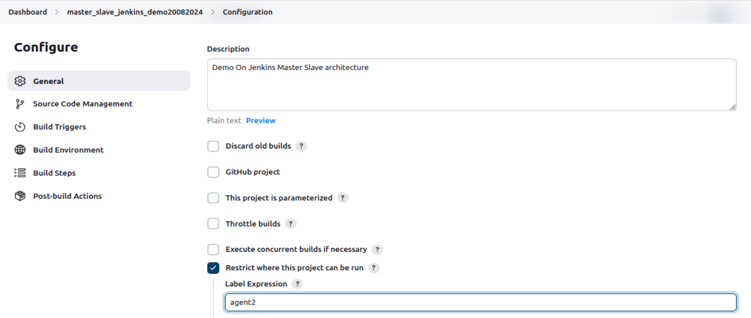

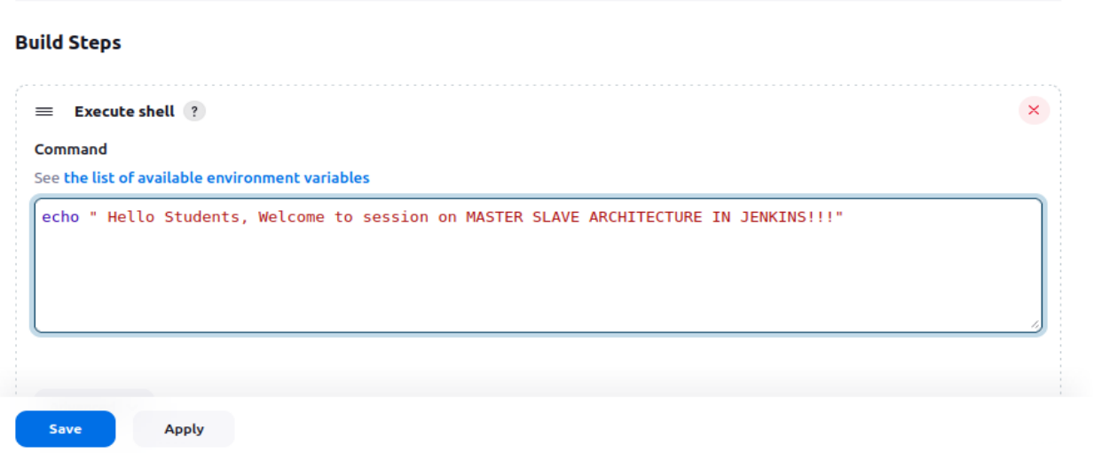

**Click on Build-Now, Console Output**

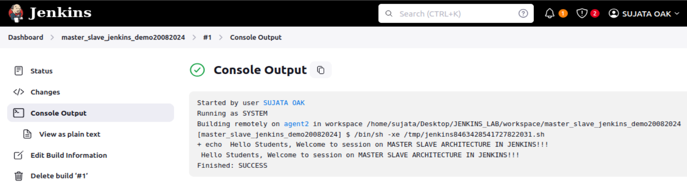

# STEP 8: Goto Jenkins Dashboard->Manage Jenkins->Nodes->agent2

# 

# Conclusion: This way we could connect with many machines as Slave nodes with different environment and execute our Jenkins jobs.